*Please Note: All of our desserts are homemade by our cook, however a fruit or yogurt pudding is available daily upon request instead of the dessert on our menu*

**Week 1**

**MENU**

Orchard Nursery School

Church Road, Ketteringham, Wymondham, Norfolk, NR18 9RS

[office@orchardnurseryschool.com](mailto:office@orchardnurseryschool.com) [www.orchardnurseryschool.com](http://www.orchardnurseryschool.com)

01603 813240

LUNCH

Savoury Mince served with New Potatoes & Seasonal Vegetables

***(Gluten, Dairy)***

Bananas & Custard

***(Dairy)***

TEA

Cheese & Ham Wraps served with Salad Sticks

***(Dairy, Gluten, Soya)***

Fruit Yogurt

***(Dairy)***

LUNCH

Ham, Cheese & Broccoli Pasta served with Sweetcorn

***(Dairy)***

Fruit Yogurt

***(Dairy)***

TEA

A Selection of Sandwiches served with Crisps & Salad Sticks

***(Dairy, Gluten)***

Flapjack

***(Gluten, Egg)***

LUNCH

Chicken Korma served with Bombay Potatoes & Vegetables

***(Dairy)***

Fruit Crumble served with Custard

***(Dairy, Gluten)***

TEA

Savoury Muffins served with Tomatoes

***(Dairy, Gluten)***

Fresh Fruit

LUNCH

Sausage Pie served with Potatoes, Green Beans & Gravy

***(Dairy, Gluten)***

Chocolate Mousse

***(Dairy)***

TEA

Soup of the day served with a Bread Roll

***(Dairy, Gluten)***

Cookie

***(Dairy, Gluten)***

LUNCH

Jacket Potato served with Grated Cheese & Baked Beans

***(Dairy)***

Shortbread Biscuit

***(Dairy, Gluten)***

TEA

Crumpets served with Cheese, Marmite & Salad Sticks

***(Gluten)***

Fruit Jelly

Friday

Thursday

Wednesday

Monday

Tuesday

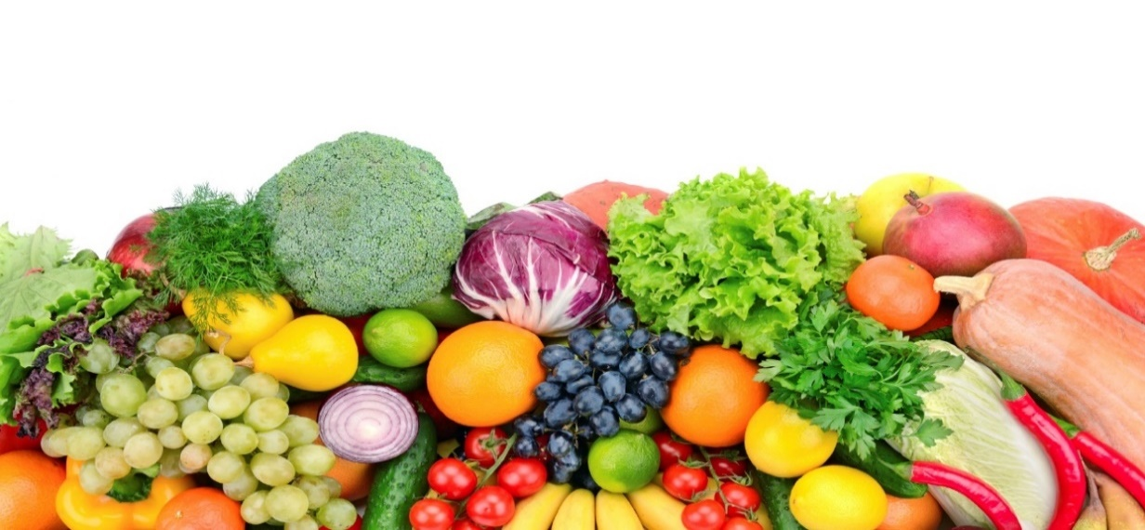

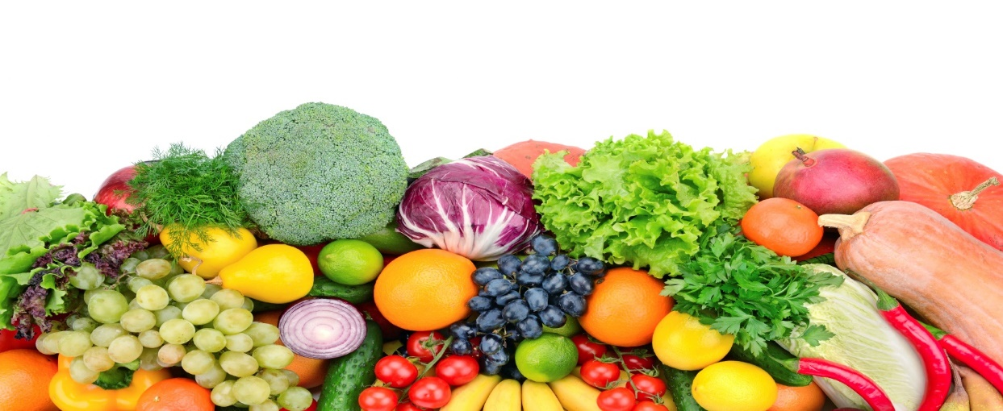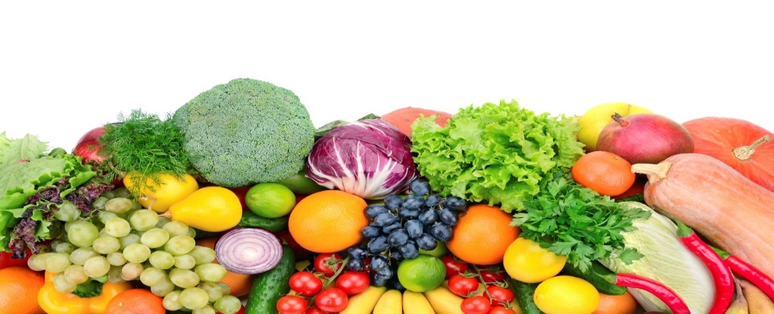



**Week 2**

**MENU**

Orchard Nursery School

Church Road, Ketteringham, Wymondham, Norfolk, NR18 9RS

[office@orchardnurseryschool.com](mailto:office@orchardnurseryschool.com) [www.orchardnurseryschool.com](http://www.orchardnurseryschool.com)

01603 813240

LUNCH

Homemade Cheese & Tomato Pizza served with Potato Wedges & Baked Beans

***(Dairy, Gluten)***

Chocolate Mousse

***(Dairy)***

TEA

Wholemeal Roll filled with Ham & Cheese, served with Salad Sticks

***(Dairy, Gluten)***

Fruit Muffin

***(Dairy, Gluten)***

Homemade Cookie

***(Dairy)***

LUNCH

Sausage & Mashed Potato, served with Garden Peas & Gravy

Fruit Flapjack

***(Dairy, Gluten)***

TEA

A selection of Wholemeal Sandwiches served with Crisps & Salad Sticks

***(Dairy, Gluten)***

Yogurt

***(Dairy)***

LUNCH

Roast Chicken served with Roast Potatoes, Yorkshire Pudding & Seasonal Vegetables

***(Gluten, Egg, Diary)***

Oat Cookie

***(Dairy, Gluten)***

TEA

Ploughman’s including Ham, Cheese, Salad Sticks & Pickle

***(Dairy, Gluten)***

Fruit Jelly

LUNCH

Beef & Vegetable Chilli Con Carne served on a Jacket Potato topped with Cheese

***(Dairy)***

Fruit Yogurt

***(Dairy)***

TEA

Croissants filled with Ham & Cheese served with Salad Sticks

***(Dairy, Egg, Gluten)***

Chocolate Crispy Cake  
***(Dairy)***

LUNCH

Mediterranean Vegetable Pasta topped with Cheese & served with Garlic Bread  
***(Gluten, Dairy)***

Angel Delight

***(Dairy)***

TEA

Chicken & Cheese Spread Wholemeal Wraps, served with Salad Sticks

***(Gluten)***

Tray Bake

***(Dairy, Gluten)***

Friday

Thursday

Wednesday

Tuesday

Monday

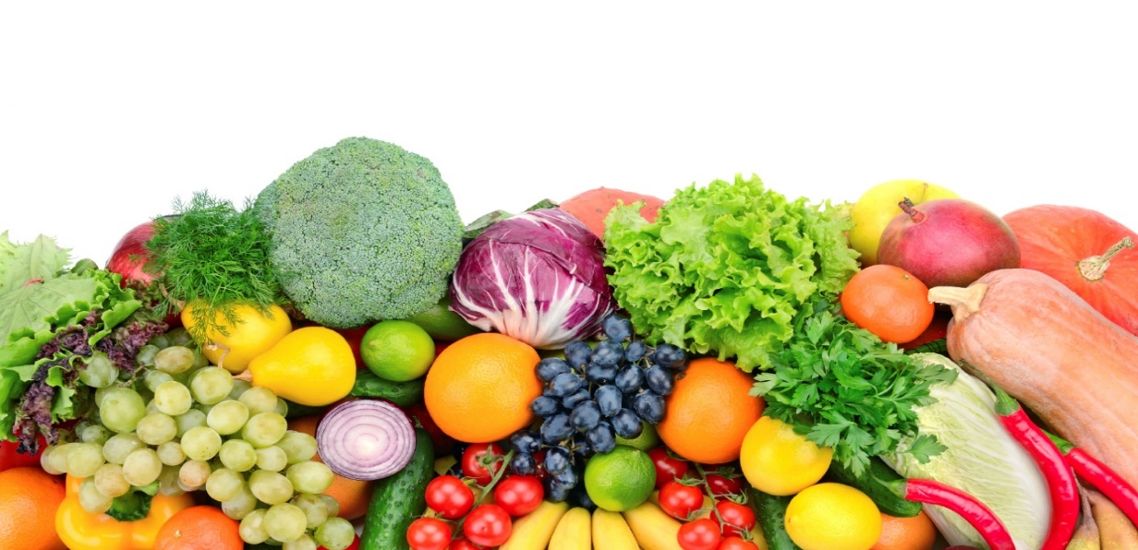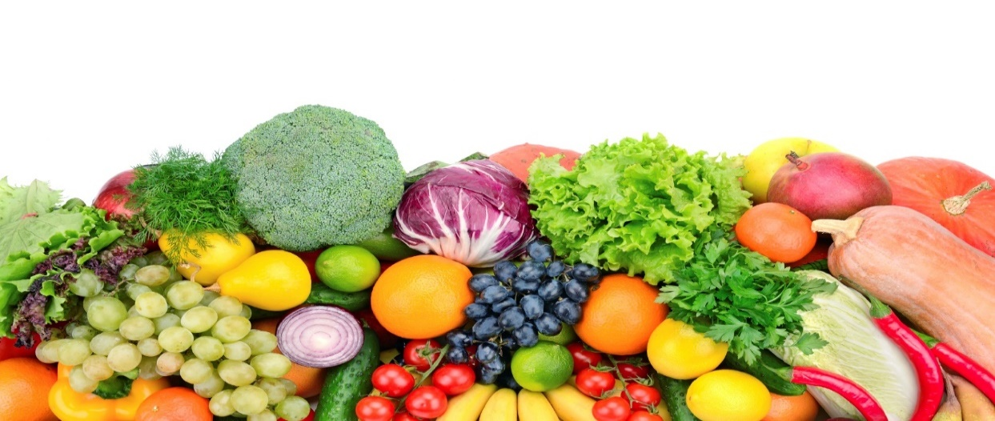

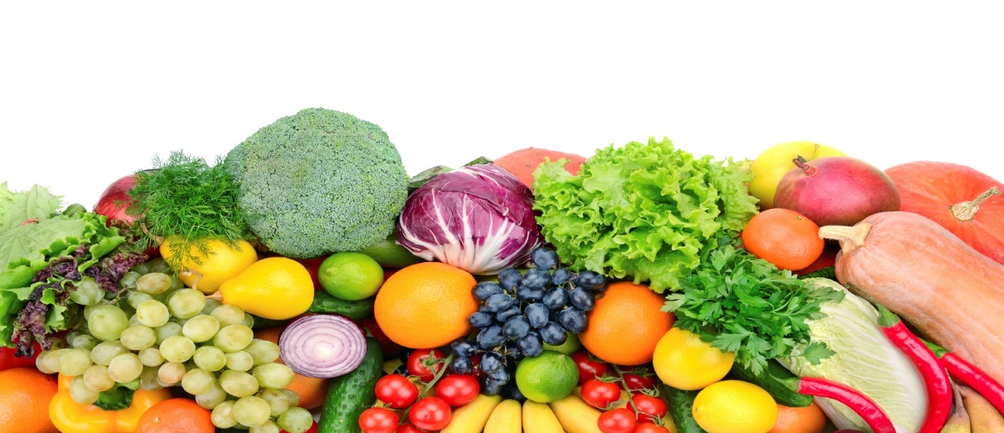

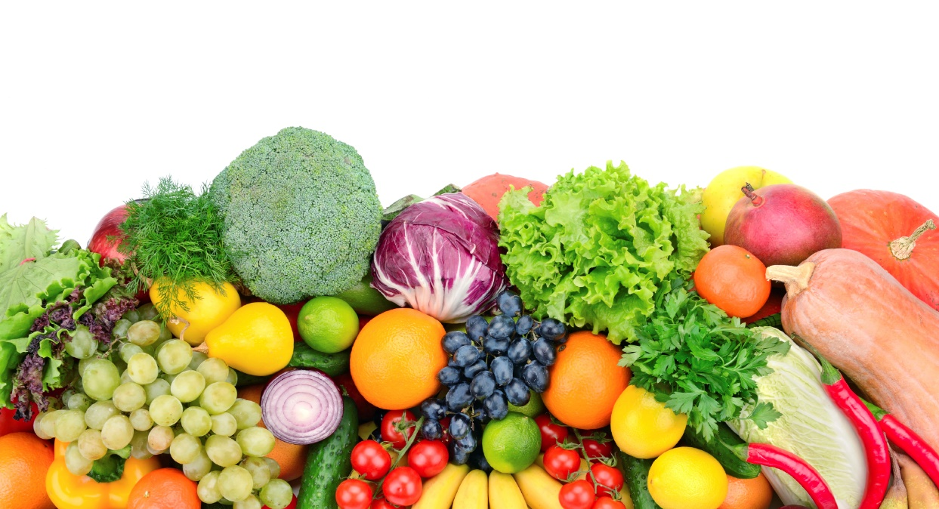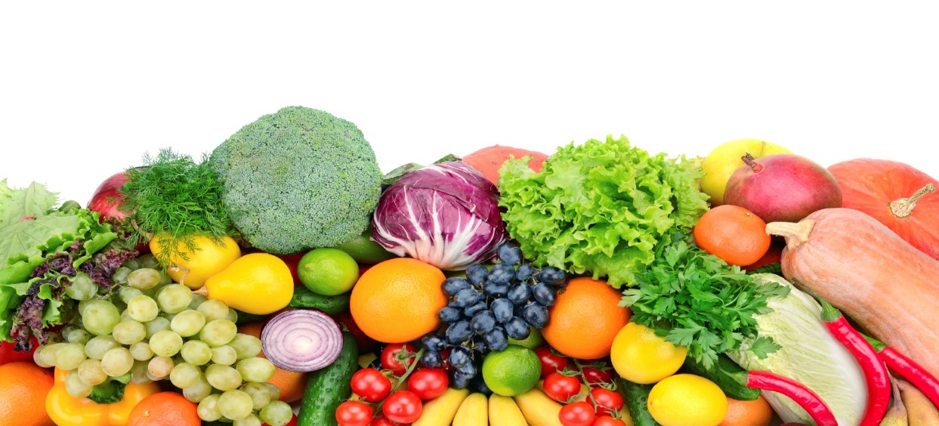

BREAKFAST

A choice of cereals & Toast

(Gluten, Milk)

LUNCH

Homemade Macaroni Cheese served with Broccoli

Apple & Cinnamon Crumble & Custard

TEA

A Selection of Wraps served with Salad Sticks

Fruit Yoghurt

BREAKFAST

A choice of cereals & Toast

(Gluten, Milk)

LUNCH

Roast Chicken served with Roast Potatoes, Carrots, Stuffing & Gravy

Mixed Berry Muffin

TEA

Spaghetti Hoops on Wholemeal Toast

Fresh Fruit Slices

BREAKFAST

A choice of cereals & Toast

(Gluten, Milk)

LUNCH

Homemade Chicken & Autumn Vegetable Stew served with Mashed Potatoes

Mixed Berry Muffins

TEA

Cheesy Jacket Potato served with Cherry Tomatoes & Cucumber Sticks

Chocolate Oat Cake with Banana Slices

BREAKFAST

A choice of cereals & Toast

(Gluten, Milk)

LUNCH

Jacket Potato served with Cheddar Cheese & Baked Beans

Chocolate Mousse

TEA

Ploughman’s Platter served with Cucumber Sticks

Bananas & Custard

Friday

Thursday



**Week 3**

**MENU**

Orchard Nursery School

Church Road, Ketteringham, Wymondham, Norfolk, NR18 9RS

[office@orchardnurseryschool.com](mailto:office@orchardnurseryschool.com) [www.orchardnurseryschool.com](http://www.orchardnurseryschool.com)

01603 813240

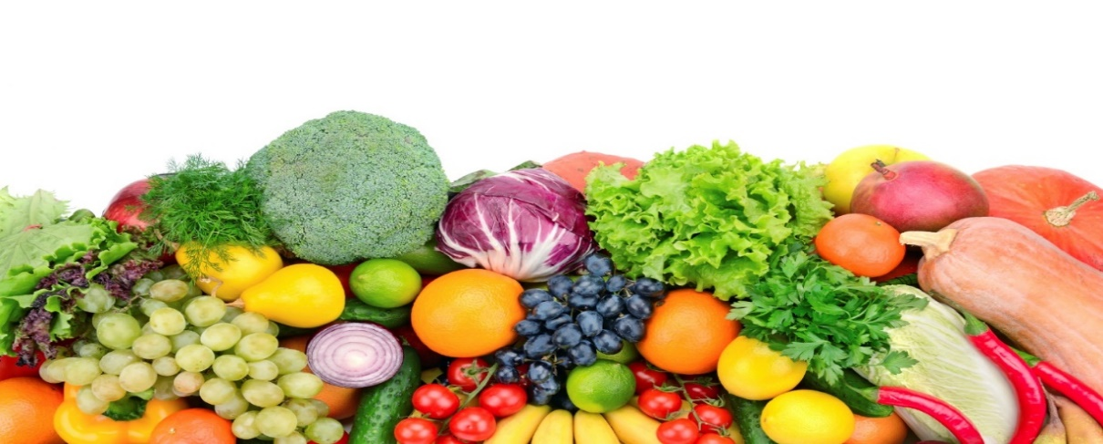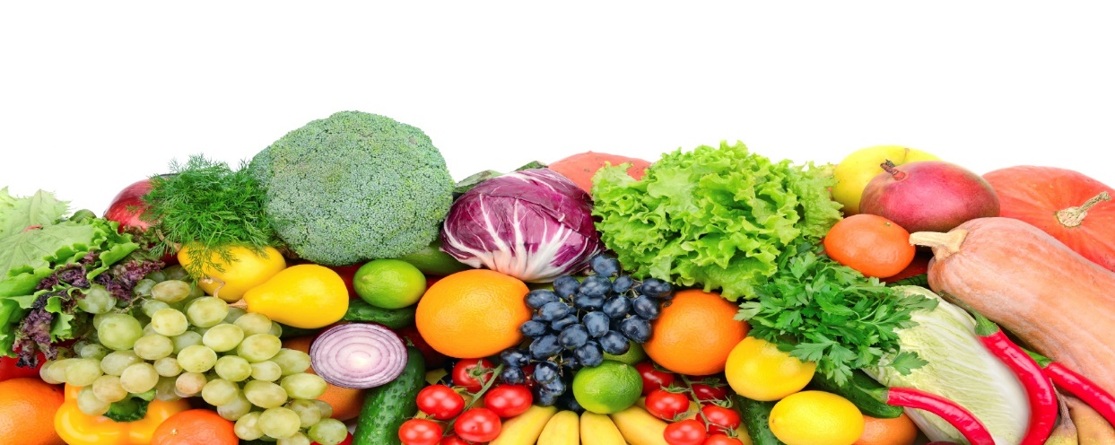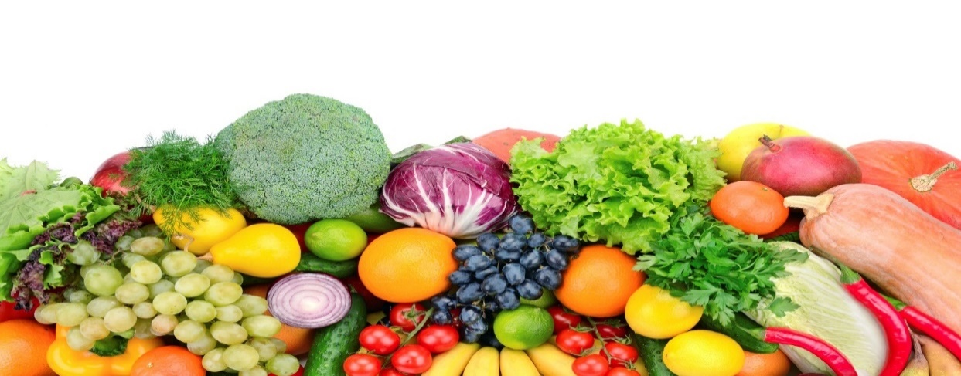

LUNCH

Chicken & Autumn Vegetable Casserole served with Boiled Potatoes

***(Dairy, Gluten)***

Gingerbread Biscuit

***(Dairy, Gluten)***

TEA

Cheesy Jacket Potato served with Salad Sticks

***(Dairy, Gluten)***

Fresh Fruit

LUNCH

Chicken Goujons served with Herby Diced Potatoes & Sweetcorn

***(Dairy, Gluten)***

Bananas & Custard

***(Dairy)***

TEA

Ploughman’s including Ham, Cheese, Salad Sticks and Pickle

***(Dairy, Gluten)***

Chocolate Oaty

***(Dairy, Gluten)***

LUNCH

Sausage & Mixed Bean Hotpot served with baby Carrots

***(Gluten)***

Fresh Fruit

TEA

Cheese & Crackers served with Grapes

***(Gluten, Dairy)***

Iced Cupcake

***(Dairy, Gluten)***

LUNCH

Fish Fingers served with Herby Wedges & Spaghetti Hoops

***(Gluten, Fish, Dairy)***

Chocolate Pudding & Chocolate Custard

***(Gluten, Dairy)***

TEA

Pizza Slices served with Salad Sticks

***(Dairy, Gluten)***

Fruit Yogurt

***(Dairy)***

LUNCH

Pasta Bolognese topped with Cheese

***(Dairy, Gluten)***

Fruit Yogurt

***(Dairy)***

TEA

Wholemeal Chicken & Cheese Rolls served with Cucumber Slices

***(Gluten, Dairy)***

Shortbread Biscuit

***(Dairy, Gluten)***

Friday

Thursday

Wednesday

Tuesday

Monday